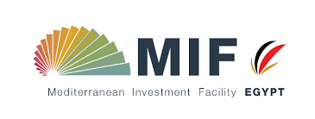
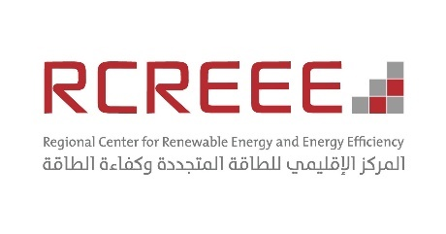
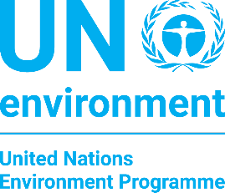

APPLICATION FORM
For the selection of two projects from the private sector at the preliminary design stage

- MIF – Egypt project
The mission of the Mediterranean Investment Facility – Egypt (MIF-Egypt) project is to develop strategies for renewable energies in Egypt and supporting mechanisms for households and communities. In particular, the energy scenarios for Egypt focus on demand reduction, peak capacity shaving and high renewable energy use in the electricity, heating and cooling sectors.
MIF-Egypt supports this trend by assisting policy makers to develop investment roadmaps for energy mixes up to 2050. By working with government bodies, communities and households on these aspects, MIF Egypt provides opportunities to save consumers money, increase a new market sector and avoid future greenhouse gas emissions.
As consequence of the above-mentioned strengthened focus on cooling needs reduction, this application form is addressed to the selection of two projects (one residential and one tertiary) from private sector at the preliminary design stage. It is part of a specific activity of the project which foresees the extension of the cooling need reduction ordinance to buildings realized by the private sector.

- Project potential benefit for project developers
Join this application form and being selected is a great opportunity for project developers. In fact, it gives the change to be part of a large-scale project which has important mission for Egypt.
Moreover, planners and technicians of the selected project will be supported in the design through dynamic simulations (performed by means of modelling platforms) of the building and HVAC (heating, ventilation and air conditioning) systems. Also support for capacity building to engineers and planners is planned.
- Application form
The following table contains the information needed for the selection procedure.
Location
Design stage¹
Expected construction works start
Building use²
N. of floors
Average floor area
Envelope technology | External walls
 | External windows
 | Roof
Cooling system description³ | Generation system⁴
 | Distribution system⁵
 | Emission system⁶
Heating system description³ | Generation system
 | Distribution system
 | Emission system
Domestic Hot Water system description³ | Generation system
Graphical representation⁷ (if available)

¹ e.g., preliminary, final, executive
² e.g., residential, office
³ please highlight if renewable energies are used (e.g. PV, solar thermal)
⁴ e.g., heat pump, boiler
⁵ e.g., water, air
⁶ e.g., radiator, fan coil
⁷ e.g., renders, drawings, sketches

- Company information
Year of company establishment

Number of building already constructed in Egypt
Main geographic areas tackled

Number of buildings planned to be constructed within the next two years
Planned geographic areas tackled

Number of years of operation in Egypt

